Working title: Tricky Fox

Concept statement: You play as a hungry fox trying to break into the farmer couple’s trapped chicken pen. But you need to be careful, as the traps get worse every day!

Genre(s): Puzzle & Adventure

Target audience: For puzzle lovers and people who enjoy a good challenge. Rated Teen

Unique Selling Points: One of the few games where you play as an actual animal, rather than an anamorphic one. It’s also a puzzle game where neither side is truly in the wrong. They both having reasons to be doing what they are doing (the fox wants food, the farmers want to protect their livestock), as told through the cutscenes.

Player Experience and Game POV: The player is a fox, and the setting is an old farm. It takes place in modern times. The game grants the fantasy of being a smart little creature that goes up against some bigger creatures and some humans, while coming out on top. The game is meant to be cute and a bit funny, inspiring the emotions of happiness and amusement. It then hits you with an emotional gut punch in the final cutscene, with the fox wondering if they will be able to keep feeding themself during winter if the traps keep getting worse and the farmers wondering about their livelihood and if they will have enough eggs to sell at the upcoming market. The extra levels are in winter, and end with the farmers relocating the fox to a new area, one without humans.

Visual and Audio Style: Done in a cartoon-esque style, meant to very much feel like you are playing out a cartoon until you reach the end of the main game. At that point, the style is meant to create a dissonance in the mind.
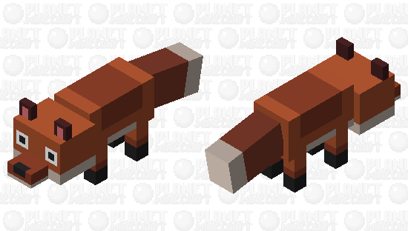 (https://www.planetminecraft.com/mob-skin/crossy-road-fox-cub/)
 (https://www.dreamstime.com/cute-stylized-cartoon-fox-rounded-form-light-blue-white-fur-has-la-large-black-eyes-small-nose-fluffy-tail-s-image373568903)
Essentially the fox will look like a more rounded version of the first image, like in the second image. It will also have the second image’s eyes.
Reference for gameplay style: Untitled Goose Game
Reference for visual style: Crossy Road & Ultimate Goat Simulator
Reference for audio style: Minecraft

Game World Fiction: Presented as a modern world, takes place on an old farm alongside the woods next to it. You are a hungry fox who has to outwit the farmers, while the farmers are just trying to make a living.

Monetization: The game will be on itch.io and will be set to “Choose your own price”.

Platform(s), Technology, and Scope (brief): Tricky Fox is a 3D PC game done in Unity, and it will take approximately four months to make.

Core Loops: The main core loop is the player trying to get into the chicken coop. It engages the player by changing every day/level.

Objectives and Progression: The main objective is to get into the chicken coop without getting caught. You move through the game using the WASD keys, alongside shift for sprint, q for bite/drag, and e for dig (those are the current known keybinds). The short-term goal is to solve the puzzle, the long-term (and implicit) goal is to get enough food for the upcoming winter.

